Phase Changes in Carbon Dioxide…”Wet” Dry Ice
Presented by Paulette Berger @ I-ACT meeting HASTI, February 5, 2009
SAFETY NOTES:
- The probability of the beral pipets exploding in this activity is very high. Goggles are to be worn at all times and you are likely to get wet if the pipet explodes!
- Dry ice is very cold(-78 C at the surface) and may cause frostbite if in direct contact with skin for more than a few seconds. Do not directly touch the substance…wear gloves and handle carefully!
Objective: A sample of dry ice will be observed as it undergoes phase changes and a kinetic theory description applied to the phenomena observed.
Introduction: Dry ice (carbon dioxide in the solid phase) is interesting to most people due to its unique triple point which prohibits it from being liquid under normal lab conditions. In this activity you will be able to view the substance as it undergoes sublimation, melting, and other phase changes.
Materials:
- Dry ice (small rice-sized pieces or powdered form) and tap water
- Gloves, goggles
- Tongs or forceps,
- Jumbo beral pipets(Flinn cat. #AP1445), scissors
- Needle-nosed pliers
- Clear plastic cup
Procedure:
- Obtain a jumbo beral pipet and cut of the tip with scissors
- Put on gloves and scoop up small pieces of dry ice through the stem (the powder works quite well, also) until the pipet is ½ to 2/3 full of the solid.
- Fill a clear plastic cup ½ full of tap water.
- Put on your goggles, fold over the stem of the beral pipet and clamp tightly with the pliers.
- Submerge the folded pipet in the cup of water. Watch for bubbles indicating a leak from your stem or pipet. If bubbles come from the stem, try to re-clamp the stem by adjusting the position or tightness of your grip.
- Observe the pipet under the water as the solid sublimes and pressure is increased.
- At some point in time, you will begin to see the melting of the dry ice and liquid forming.
- At this point try to release some pressure on the stem and attempt to reverse the process.
- If pressure is not released, the pipet will rupture and a fountain of water will be produced. When/if this happens, observe the contents of the damaged pipet and note what you see.
- With some patience and skill you may be able to repeat the processes of freezing and melting multiple times, provided your pipet does not explode early in the process.
- Place a small piece of dry ice on the lab counter top and observe, then drop the piece in your cup of water and observe for a few minutes. Record you observations.
- Using your observations, complete the questions on the report sheet.

Laboratory Activity: Name: ______________________
Phase Changes in Carbon Dioxide Class: ______________________

Observations:

Questions:
1. How is the melting of dry ice different from that of water ice? Why is this so?

2. What was the function of the water in the cup?

3. When dry ice is submerged in water, what causes the “smoke/fog” that forms?

4. Consider two identical dry ice chips: Which would sublime faster...one submerged in water or one placed on the counter top? Support your answer.

5. Using the phase diagram at the bottom of this page as a “map”, trace the path of the CO₂ as it was observed in this activity. Use arrows to indicate the path direction as time passed.
Label the following points on your graph:
1) Starting point for the activity
2) Point at which liquid began to be visible
3) Point immediately after system was vented or pipet exploded
4) Point at which system finally reached equilibrium (endpoint)

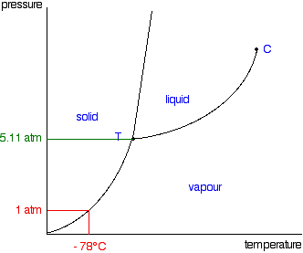

Teacher Notes:

- Dry ice may be purchased from local ice supply companies (Home City Ice in Indy) or at times from local stores such as Meijer or Cosco which receives shipments packed in it. Prices will vary with the vendor...usually priced per pound. I use about 10 lb. for 20 students (minimum purchase price) and have plenty left for other demos.
- Beral pipets may be found from any science supply vendor. Be sure to order Jumbo pipets with wide stems so that you can get the fragments/powder in the stem.
- I ask students to bring in needle-nosed pliers...or sharing one pair does not work well.
- Students will want to explode the pipets...be prepared to mop up water (I found a squeegie works very nicely on table tops and I have a mop/bucket nearby for the floor).
- Photos of the students with erupting pipets engage the students...I usually have a camera nearby to attempt to catch the explosion...some students were able to catch it on their cell phones...watch out U-Tube!
- I have some photos below of the process in action.

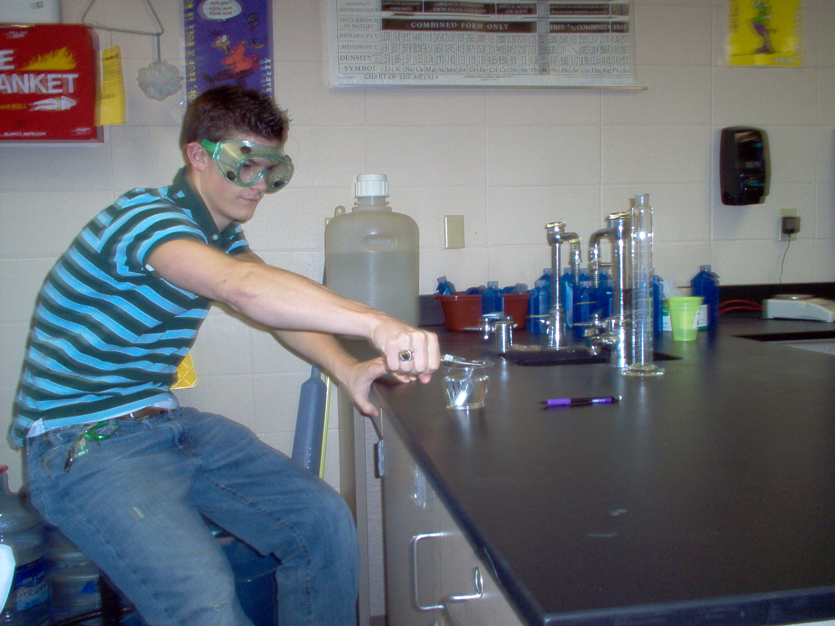

Waiting....

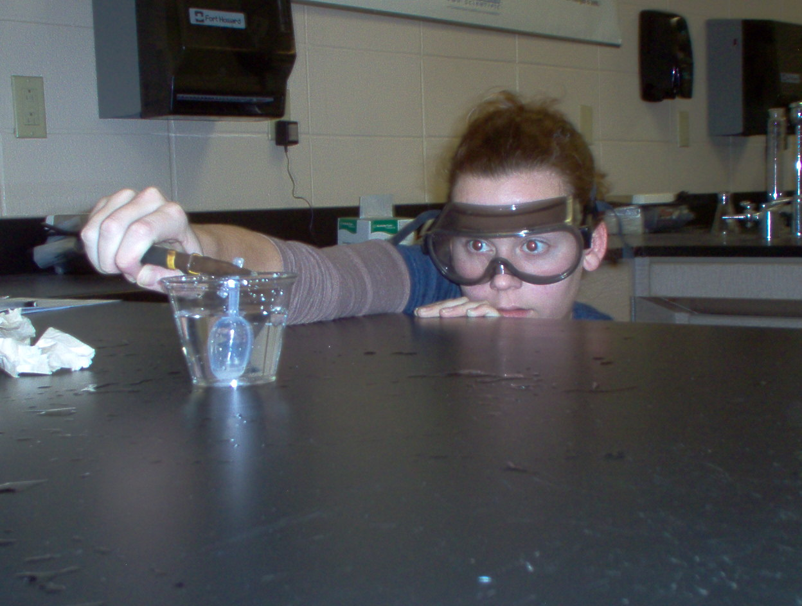

Almost there.....
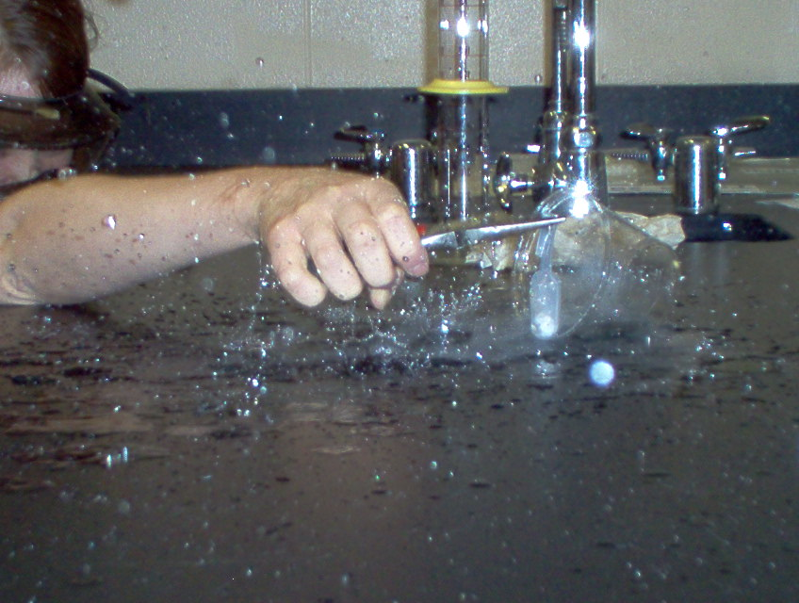
Thar’ she blows!

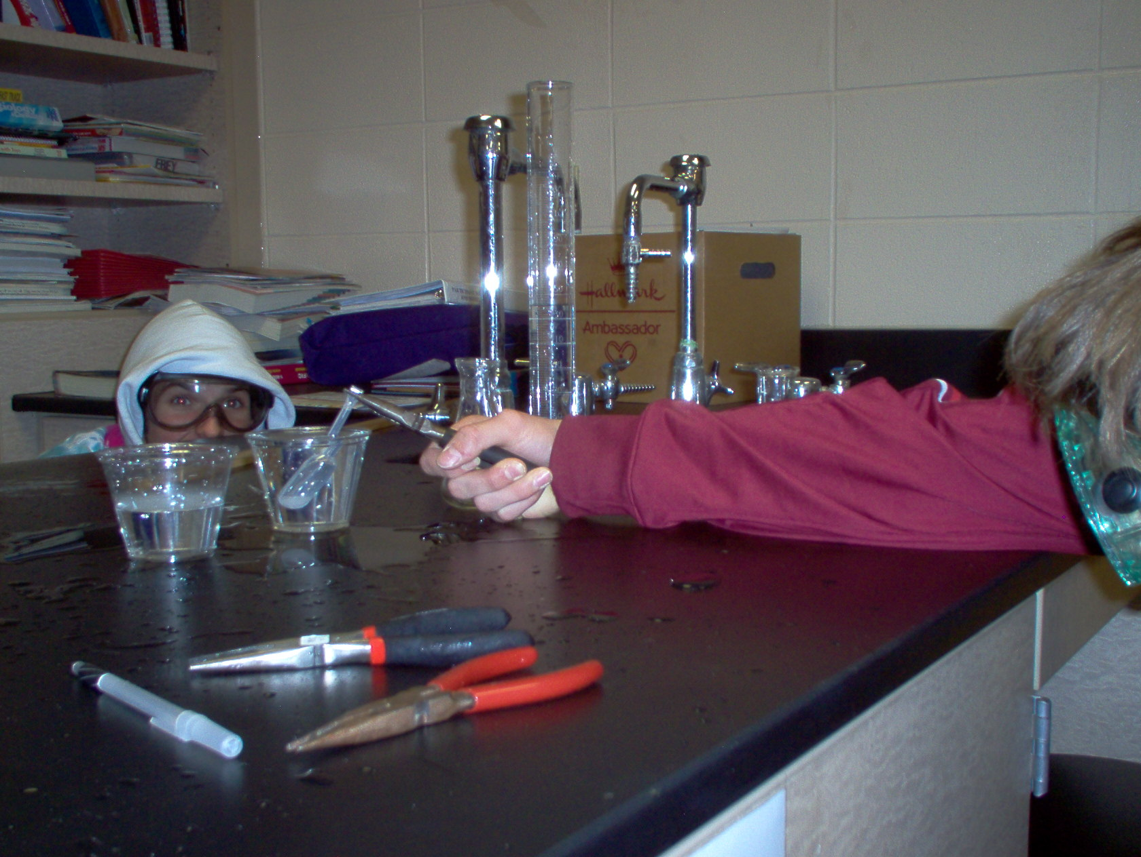
Again!!!!

